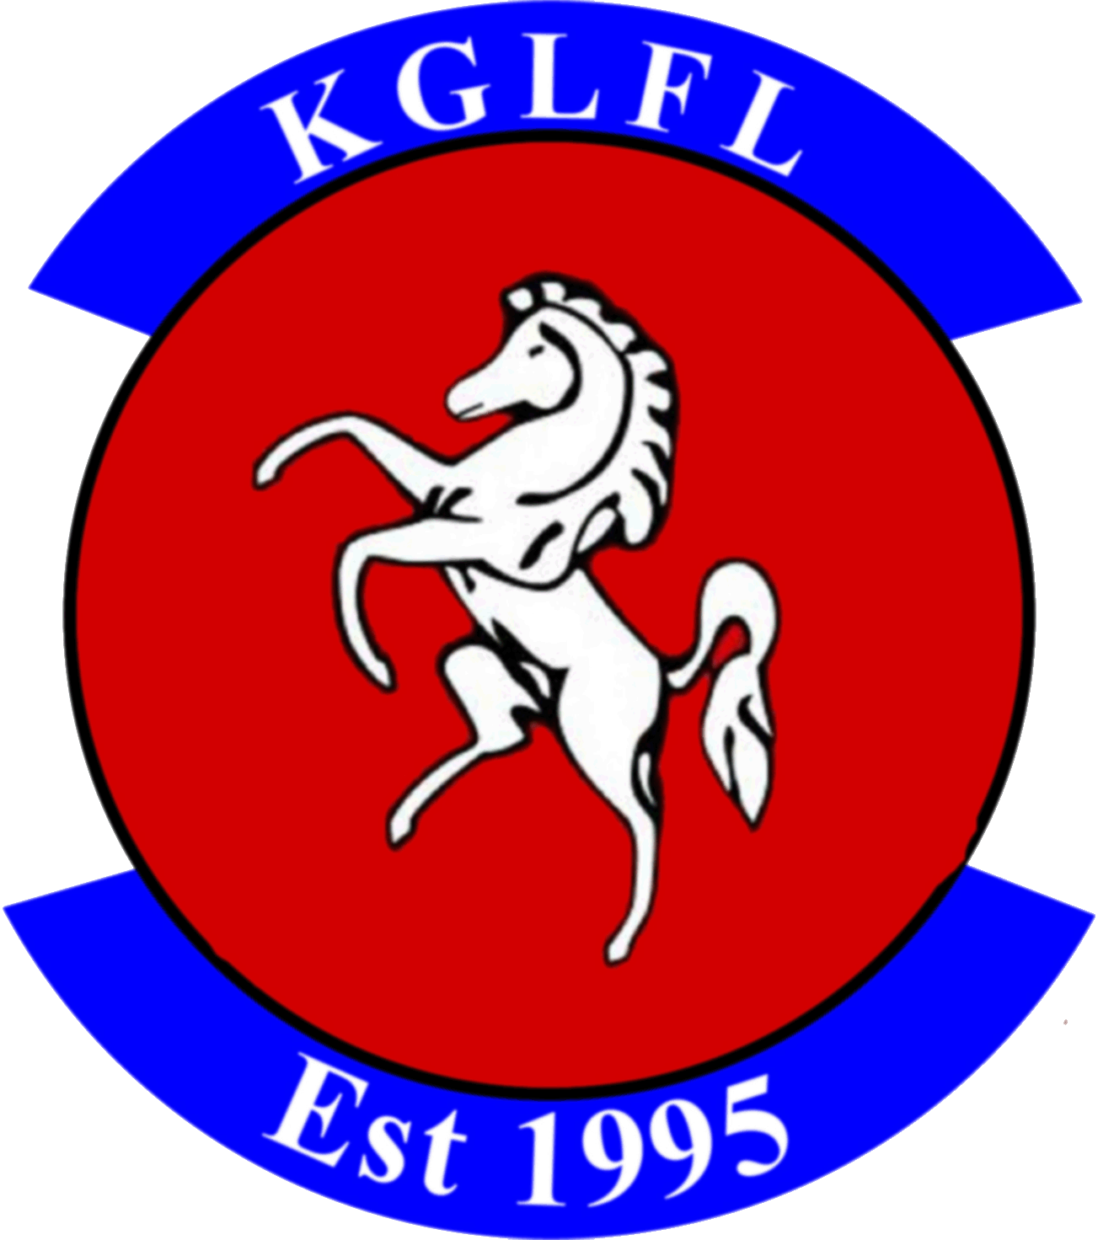
Kent Girls and Ladies Football League Privacy Policy

League Privacy Notice
Kent Girls and Ladies Football League ("we", "our", "us") take your privacy very seriously.
This Privacy Notice sets out how we use and look after the personal information we collect from you. We are the data controller, responsible for the processing of any personal data you give us. We take reasonable care to keep your information secure and to prevent any unauthorised access to or use of it.

What personal data we hold on you
Personal data means any information about an individual from which that individual can be identified.
We collect, use, store and transfer some personal data of our participants [and their parents or guardians], and other League members.

You provide information about yourself and your members when you register with the League, and by filling in forms at an event or online, or by corresponding with us by phone, e-mail or otherwise.

The information you give us may include name, date of birth, address, e-mail address, phone number, gender, and the contact details of a third party in the case of emergency. We may also ask for relevant health information, which is classed as special category personal data, for the purposes of health, wellbeing, welfare and safeguarding. Where we hold this data it will be with the explicit consent of the participant or, if applicable, the participant’s parent or guardian.

Where we need to collect personal data to fulfil League responsibilities and you do not provide that data, we may not be able honour or administer your registration.

Why we need your personal data
We will only use personal data for any purpose for which it has been specifically provided.

The reason we need participants’ and members’ personal data is to be able to run the football league and arrange matches; to administer registration, and provide the league services you are signing up to when you register with the League as a club or participant. Our lawful basis for processing this personal data is that we have a contractual obligation to anyone as a participant or member to provide the services they are registering for.

We have set out below, in a table format, a description of all the ways we plan to use personal data, and which of the legal bases we rely on to do so. We have also identified what our legitimate interests are where appropriate.

Purpose/ Processing Activity | Lawful Basis for processing under Article 6 of the GDPR.
processing registration forms | Performance of a contract
organising matches | Performance of a contract
sending out match or League information and updates | Performance of a contract
to check compliance with our League criteria to participate in the League | Performance of a contract and Legitimate Interests.
sharing data with referees | Performance of a contract
sharing data with the club you are a member of, county football associations and the FA | Performance of a contract
sharing data with committee members to provide information about league activities, registration renewals or invitation to social events | The League has a legitimate interest to maintain participant correspondence for league community purposes.
sharing data with third party service or facility providers | The League has a legitimate interest to run the organisation efficiently and as it sees fit. Provision of some third party services is for the benefit of the League and participants.
sharing anonymised data with a funding partner as condition of grant funding e.g. Local Authority | The League has a legitimate interest to run the organisation efficiently and as it sees fit. Application for funding is a purpose that benefits the League and participants.
publishing match and league results | Consent. We will only publish personal data in a public domain, including images and names, if we have your consent for us to do so. In the case of children under the age of 13 then only with written consent of parent/guardian
sending out marketing information such as newsletters and information about promotions and offers from sponsors | Consent. We will only send direct marketing if you are an existing member, participant or other associated individual and you have not previously objected to this marketing, or, you have actively provided your consent.
to ensure we understand possible health risks | Consent. We will only process details on anyone medical history with their consent.

Who we share your personal data with
When you register with the League, your information, if you are a coach or volunteer will be or if you are another participant may be entered onto the Whole Game System database, which is administered by the FA. We also pass your information to the County FA/ FA for affiliation purposes.

We may share personal data with selected third parties, suppliers and sub-contractors such as, coaches or match organisers. Third-party service providers will only process your personal data for specified purposes and in accordance with our instructions.

We may disclose personal information to third parties to comply with a legal obligation; or to protect the rights, property, or safety of our participants, members or affiliates, or others.

The League’s data processing may require personal data to be transferred outside of the UK. Where the League does transfer personal data overseas it is with the sufficient appropriate safeguards in place to ensure the security of that personal data.

Protection of your personal data
We have put in place appropriate security measures to prevent personal data from being accidentally lost, used or accessed in an unauthorised way, altered or disclosed.

How long we hold your personal data
We keep personal data on our participants while they continue to be a participant or are otherwise actively involved with the League. We will delete this data 1 year after a participant has left or otherwise ended their registration or affiliation, or sooner if specifically requested and we are able to do so. We may need to retain some personal data for longer for legal or regulatory purposes. The personal data that is stored on Whole Game System is subject to the FA’s privacy policy so we advise you review that policy together with this notice. If anyone would like their personal data to be deleted from Whole Game System then please contact the County FA.

Your rights regarding your personal data
As a data subject participants may have the right at any time to request access to, rectification or erasure of their personal data; to restrict or object to certain kinds of processing of their personal data, including direct marketing; to the portability of their personal data and to complain to the UK’s data protection supervisory authority, the Information Commissioner’s Office about the processing of their personal data.

As a data subject participants are not obliged to share their personal data with the League. If they choose not to share their personal data with us we may not be able to register them with the League.

We may update this Privacy Notice from time to time, and will inform you to any changes in how we handle personal data.

If participants have any questions about this Privacy Notice then please contact the League Secretary.

